30th April 2013

**YOKOHAMA Holds Signing Ceremony to Build New Tyre Plant in Mississippi**

Tokyo – The YOKOHAMA Rubber Co., Ltd., announced today that it signed an agreement with the State of Mississippi of the United States to build a truck/bus tyre plant in Mississippi on April 29, 2013. Hikomitsu Noji, president and representative director of YOKOHAMA Rubber and Mississippi Gov. Phil Bryant as well as other officials of the State attended the signing ceremony held at the West Point Ritz near the site of the future company plant, about 149 miles from Jackson, MS, the state capitol.

“This is a historic day for YOKOHAMA,” said Noji. “Since our entry into the U.S. market over 40 years ago, along with the subsequent acquisition of our plant in Salem, Virginia in the 1980s, YOKOHAMA has been on a continual growth. Now we will build a factory in the United States for the first time. It re-affirms our commitment to the North American market and to the continued mutual success of YOKOHAMA and its business partner – our dealers. I’d like to thank Gov. Phil Bryant and the State of Mississippi for their dedication in bringing this to fruition. I’d like to thank Mississippi as well for a very warm welcome.”

“I am honored YOKOHAMA has selected our state for its second U.S. tyre manufacturing facility,” said Gov. Bryant. “This new plant will have a tremendous impact on the Golden Triangle region and on our state as a whole, and I welcome this highly-respected company to Mississippi and look forward to our partnership in the years to come.”

The plant will be built on over 500-acre land with construction expected to begin in September and completion two years later or in October 2015. The facility, which is expected to produce one million tyres starting in 2015, will have an initial capital investment of $300 million and potential plant expansions could reach up to four times the original employment and investment levels.

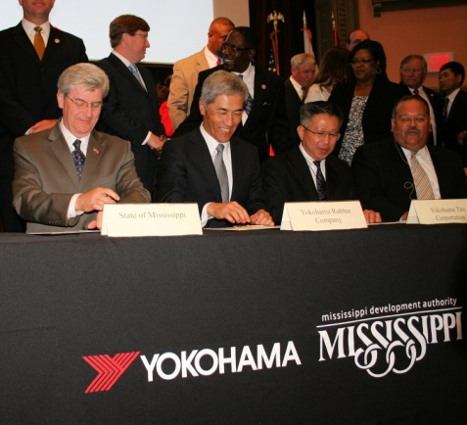

Hikomitsu Noji, President of YOKOHAMA Rubber (second from left) and Phil Bryant, Mississippi Gov. (left) at the signing ceremony.